Linux System Administration -I

- Operating System Administration
- Operating System
- Difference between Linux and windows operating system
- History of Unix/Linux
- Features of Unix
- Architecture of Unix/Linux System
- Hierarchical File Structure

- Linux Essentials
- Redhat Linux Desktop Installation
- Accessing The Linux System

- Basic commands of Linux System
- Working with Files and Directories

- Text Processing Tools (Utilities)
- Basic Linux Networking Tools

Operating System Administration
Operating System is software and it is an interface between User and Computer. It communicates with hardware and allows other programs to run.
Operating Systems are two types:
- Client Operating Systems : It uses services provided by the Server OS.
Eg:- Windows98, Windows2000, Windows7, Windows 8, Windows vista and Windows10
Ubuntu, Linux GNOME/KDE,
- Server Operating Systems: It provides services to the client Os.
Eg:- WindowsNT, Windows 2003, Windows 2008 and Windows 2012.
Linux, Ubunt LTS, IBM AIX, SunSolaris etc.,
Difference between Linux and Windows Operating Systems.
Differences | Linux | Windows
Cost  Development and Distribution | Linux can be freely distributed, downloaded freely, distributed through magazines, Books etc. There are priced versions for Linux also, but they are normally cheaper than Windows.  Linux is developed by Open Source development i.e. through sharing and collaboration of code and features through forums etc and it is distributed by various vendors. | $119 - $199.99, $69 for students, $99 to upgrade to pro  Developed and distributed by Microsoft.

Differences | Linux | Windows
Manufacturer  User  Introduction  Company / developer  Usage  Available language(s) | Linux kernel is developed by the community. Linus Torvalds oversees things.  Everyone. From home users to developers and computer enthusiasts alike.  Linux is a Unix-like and POSIX-compliant computer operating system assembled under the model of free and open source software development and distribution. The defining component of Linux is the Linux kernel, an operating system kernel first released  Linus Torvalds and the Linux community.  Linux can be installed on a wide variety of computer hardware, ranging from mobile phones, tablet computers and video game consoles, to mainframes and supercomputers.  Multilingual | Microsoft  Everyone  Microsoft Windows is a series of graphical interface operating systems developed, marketed, and sold by Microsoft. Microsoft introduced an operating environment named Windows on November 20, 1985 as a graphical operating system shell for MS-DOS.  Microsoft  On PC's desktops, laptops, servers and some phones.  Multilingual

 | Differences |  | Linux | Windows
 | File system support  Text mode interface  Preceded by  Default user interface  Update method  License  Source model  Supported platforms |  | Ext2, Ext3, Ext4, Jfs, ReiserFS, Xfs, Btrfs, FAT, FAT32, NTFS  BASH (Bourne Again SHell) is the Linux default shell. It can support multiple command interpreters.  Basic Terminal (CLI)  Gnome or KDE  Many  GNU General Public License  Free Software  All | FAT, FAT32, NTFS, exFAT  Windows uses a command shell and each version of Windows has a single command interpreter with dos-like commands, recently there is the addition of the optional PowerShell that uses more Unix-like commands.  MS-DOS  Graphical (Windows Aero)  Windows Update  Proprietary  Closed / Shared source  PowerPC: versions 1.0 - NT 4.0; DEC Alpha: versions 1.0 - NT 4.0; MIPS R4000: versions 1.0 - NT 4.0; IA-32: versions 1.0 - 8; IA-64: version XP; x86-64: versions XP - 8; ARM: version RT;
Difference |  | Linux |  |  | Windows
OS family  Programmed in  Marketing target  Compatibility |  | GNU  C,  Server, Personal,  New version of linux support many kinds of hardware |  |  | DOS  Assembly, C, C++  Personal, business  Can coexist on local networks with Windows, BSD, Macs, and other Unix-like systems. Sometimes file compatibility issues may arise.

History of UNIX:
Before development of UNIX operating system AT & T Bell Labs, Software Team lead by Kenn Thomson, Dennis Ritchie and Rudd Canday worked on MULTICS project. MULTICS stands for Multi Information Computing System. The aim of this project is to share the same data by ‘n’ number of users at the same time. Initially, MUTICS was developed for only two users. Based on the same concept in 1969, UNICS Operating System was developed for hundreds of users. UNICS stands for Uniplexed Information Computing System. Initially UNICS was written Assembly language. In 1973, they rewritten in ‘C’ language named as UNIX.
History of Linux :
The history of Linux began in 1991 with the commencement of a personal project by Finnish student Linus Torvalds to create a new free operating system kernel. Since then, the resulting Linux kernel has been marked by constant growth throughout its history. Since the initial release of its source code in 1991, it has grown from a small number of C files under a license prohibiting commercial distribution to the 4.2.3 version in 2015 with more than 18 million lines of source code under the GNU General Public License .
Features of UNIX:-
- Multi User capability
- Multi Tasking Capability
- Programming Facility
- Portability
- Communication (Electronic Mail)
- Security
- Open System
- System Calls
- Help Facility.

Multi User: Multi user operating system means more than user shares the same system resources (hard disk, memory, printer, application software etc.,) at the same time.
Multi tasking: Another highlight of Unix is that it is Multitasking, implying that it is capable of carrying out more than one job at the same time. It allows you type in a program in its editor while it simultaneously executes some other command you might have given earlier, say to sort and copy a huge file. The latter job is performed in the ‘background’, while in the ‘foreground’ you use editor, or take a directory listing or whatever else.
Depending on the priority of the task, the operating system appropriately allots small time slots to each foreground and background task.
Programming facility: UNIX o/s provides shell. Shell works a programming language. it provides commands and key words. By running these two, user can prepare efficient program.
Portability: one of the main reason for the universal popularity of Unix is that it can be ported to almost any computer system, with only the bare minimum of adoptions to suit the given computer architecture. It works with 8088 processors to super computer.

Communication: UNIX provides electronic mail. The communication may be within the network of a single main computer, or between two are more such computer networks. The user can easily exchange mail, data, programs thro such networks. You may be two feet away or two Thousands miles your mail with hardly take any time to reach its destination.
Security: UNIX provides three levels of security to protect data. The first is provided by assigning passwords and login names to individual users ensuring that not anybody can come and have access to your work.
At the file level, there are read, write and execute permissions to each file which decide who can access a particular file, who can modify it and who can execute it.
Lastly, there is file encryption. This utility encodes your file into an unreadable format, so that even if someone succeeds in opening it, your secrets are safe.
Open system: The source code for the UNIX System, and not just the executable code, has been made available to users and programmers. Because of this many people have been able to adapt the UNIX system in different ways. This openness has led to the introduction of a wide range of new features and versions customized to meet special needs. It has been easy for developers to adapt to UNIX, because the computer code for the UNIX system is straight forward, modular and compact.
System Calls: Programs interact with the kernel through approximately 100 System calls. System calls tell the kernel to carry out various tasks for the program, such as opening a file, writing to a file, obtaining information about a file, executing a program, terminating a process, changing the priority of a process, and getting the time of day. Different implementations of UNIX system have compatible system calls having the same functionality. However, the internals, programs that perform the function of system calls(usually written in the c language).
Help facility: Unix provides manual pages for UNIX commands.
Architecture of UNIX/Linux system
Shell: The shell reads your commands and interprets them as requests to execute a program or programs, which it then arranges to have carried out. Because the shell plays this role, it is called a command interpreter. Besides being a command interpreter, the shell is also a programming language. As a programming language, it permits you to control how and when commands are carried out shell acts as an interface between user and the kernel.
Kernel: The kernel is the part of the operating system that interacts directly with the hardware of a computer, through device drivers that are built into the kernel. It provides set of services that can be used by programs, insulating these programs from the underlying hardware. The major functions of the kernel are to manage computer memory, to control access to the computer, to maintain file system, to handle interrupts, to handle errors, to perform input and output services and to allocate the resources of the computer among users. Programs interact with the kernel through approximately 100 system calls. System calls tell the kernel to carryout varies tasks for the program, such as opening a file, writing to a file, obtaining information about a file, executing a program, terminating a process, changing the priority of a process and getting the time of day.
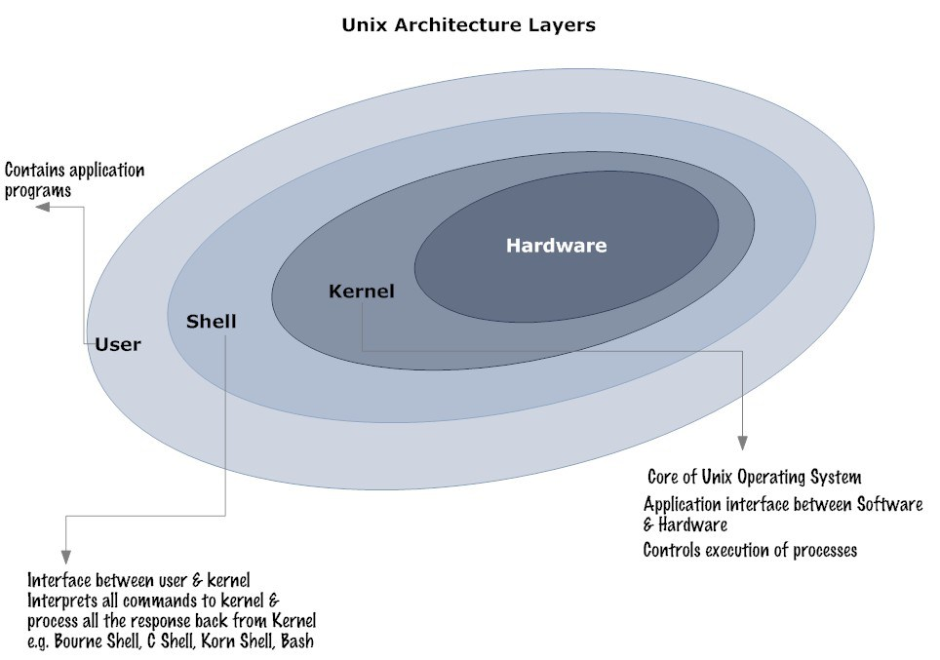

The UNIX File System
A file is the basic structure used to store information on the UNIX system. Technically, a file is a sequence of bytes that is stored somewhere on a storage device, such as a disk. The UNIX file system provides a logical method for organizing, storing, retrieving, manipulating and information. A file can store manuscripts and other word processing documents, instructions or programs for the computer itself, an organized database of business information, a bit map description of a screen image or any other kind of information stored as sequence of bytes on a computer. Files are organized into a hierarchical file system, with files grouped together into directories. Within UNIX there are three different types of files
- Regular files
- Directory files
- Special files
Ordinary files: As a user, the information that you work with will be stored as an ordinary file. Ordinary files are aggregates of characters that are treated as a unit by the UNIX system. An ordinary file can contain normal ASCII characters such as text for manuscripts or programs. Ordinary file can be created, changed, or deleted as you wish.
Directory files: Directory is a file that holds other files and contain information about the locations and attributes of these other files. For example, a directory includes a list of all the files and subdirectories that it contains, as well as their addresses, charactesristics, file types, and other attributes.
Special files: special files constitute an unusual feature of the UNIX file system. A special file presents a physical device. It may be terminal, a communications device, or a storage unit such as disk drive. From the user’s perspective, the UNIX System treats special file just as it does ordinary files; that is, you can read or write to devices exactly the way you read and write them to an ordinary files. You can take the characters typed at your keyboard and write them to an ordinary file or a terminal screen in the same way. The UNIX system takes these read and write commands and causes them to activate the hardware connected to the device.
The Hierarchical File Structure
The UNIX file system called as hierarchical file system. In fact, within the UNIX system, there is no limit to the number of files and directories you can create in a directory that you own. File systems of this type are often called tree- structured file systems, because each directory allow you to branch off into other directories and files. The UNIX file system resembles an upside down tree.
/(root): This is the root directory of the file system, the main directory of the entire file system, and the root directory for the superuser.
/bin: bin stands for binary. This directory contains executable files for most of the Unix commands. Can be either C program or shell programs. Shell program are nothing but a collection of server Unix commands.
/etc: This contains system administration and configuration databases.
/dev: This contains the special(device) files that include terminals, printers, and storage devices. These files contain device numbers that identify devices to the operating system, including:
/dev/console the system console
In UNIX, similar devices are located in subdirectories of /dev. For example, all disk devices are in the subdirectory /dev/dsk.
/lib: This directory contains all the library functions provided by unix for programmers. The programs written under Unix make use of these library functions in the lib directory.
/sbin: This contains programs used in booting the system and in system recovery.
/opt: This is root for the subtree containing the add-on application package.
/home: This contains the home directories and files of all users. If your logname is tecno, your default home directory is /home/tecno.
/tmp: This contains all temporary files used by the UNIX system.
/mnt: Contains entries for removable(mountable) media such as CD-ROMs and DLT tapes.
/unix: This Directory contains unix kernel programming.
/usr: This contains other accessible directories such as /usr/lib and /usr/bin.
/usr/bin: contains many executable programs and UNIX system utilities.
/usr/games: contains binaries for game programs and data for games.
/usr/lib: contains libraries for programs and programming languages.
/usr/sbin: contains executable programs for system administration.
/usr/share/man: contains the online manual pages.
/var: This contains the directories of all files that vary among systems. These include files that log system activity, accounting files, mail files, application packages backup files for editors, and many other types of files that vary from system to system. Files in this directory include:
/var/adm: contains system logging and accounting files.
/var/mail: contains user mail files.
/var/news: contains messages of common interest.
/var/opt: is the root of a subtree containing add-on application packages.
/var/tmp: is a directory for temporary files.
/var/uucp: contains log and status files for the UUCP system.

II. LINUX ESSENTIALS
Red hat Linux Desktop Installation:

Before we start the installation of Linux, we have to follow below steps:
- Insert the CD/DVD of the OS (Red hat Linux ) and reboot the system.
- Hit on DEL or F2 button to go into the BIOS setup.
- In BIOS select the First boot device as CD/DVD and save and exit by pressing the F10 key.
- It will load the OS and follow below steps.
1. Select Install or upgrade an existing system option on Grub Menu
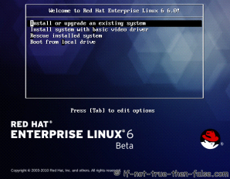
2. Choose a language

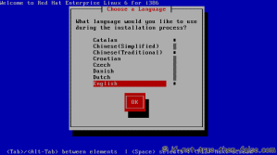

3. Choose a keyboard type
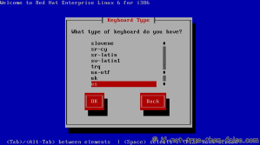
4. Choose a installation media
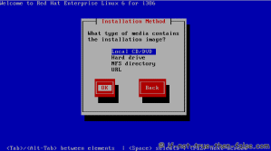5. Skip DVD media test (or select media test, if you want to test installation media before installation)
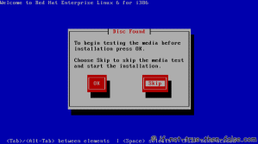
6. Red Hat 6 graphical installer starts, select next
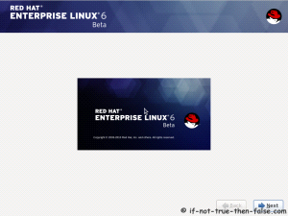
7. Accepct Pre-Release Installation

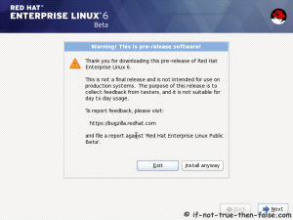
8. Select storage devices

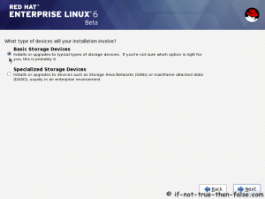
9. Insert computer name

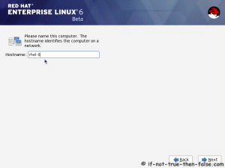

10. Select time zone

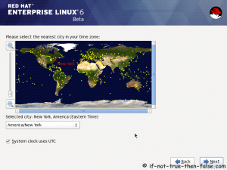
11. Enter a password for root user

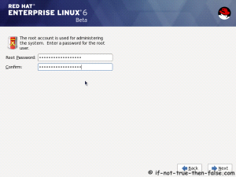

12. Select type of installation

Read every options info carefully. And select encrypting if needed and option to review and modify partition layout.

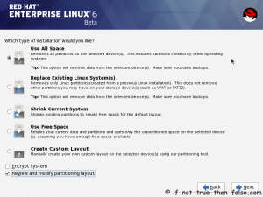
13. Review partition layout
Modify if needed. Default setup with ext4 and LVM looks good for desktop machine.

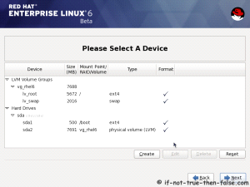
14. Accept write changes to disc
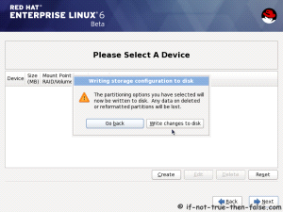
15. Writing changes (creating partitions) to disc
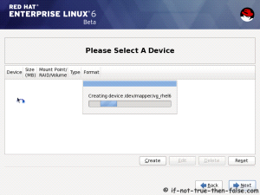
16. Configure boot loader options
Select device to install bootloader and check/create boot loader operating system list.
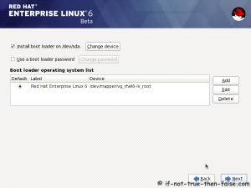
17. Select softwares to install and enable repositories
This case we select Software Development Workstation and enable Red Hat Enterprise Linux 6.0 Beta Repository and select Customize now.
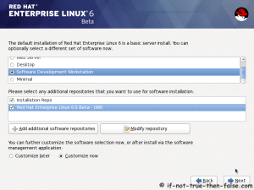
18. Customize package selection
Select PHP and Web Server to installation.

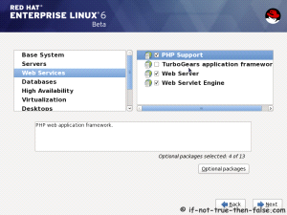
Select MySQL and PostgreSQL Databases.
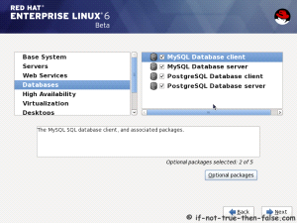
Select set of Development tools like Eclipse IDE.
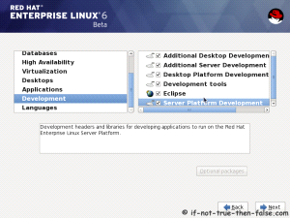
19. Checking dependencies for installation
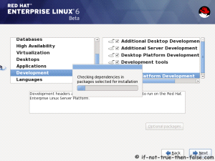
20. Starting installation process
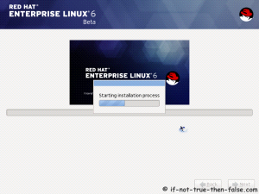
21. Installing packages
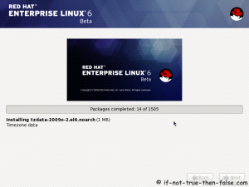
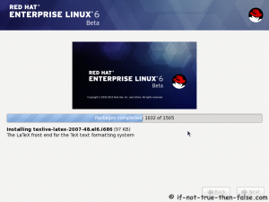
22. Installation is complete
Click reboot computer and remove installation media.
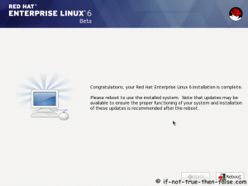
Red Hat 6 RHEL Finishing Installation
23. Selecting RHEL 6 from grub

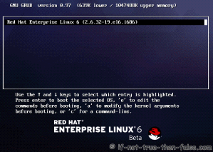
24. Booting Red Hat 6


25. Red Hat 6 Welcome screen
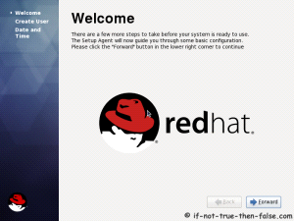
26. Create normal user

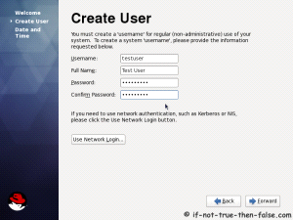
27. Setup date and time and keep up-to-date with NTP

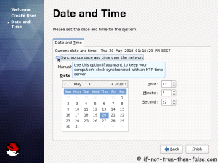
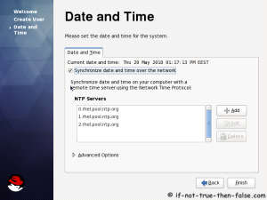
28. Login Red Hat 6 Gnome Desktop

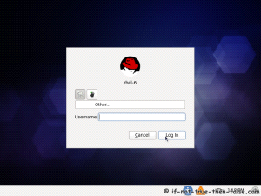
29. Red Hat (RHEL) 6 Gnome Desktop, empty and default look

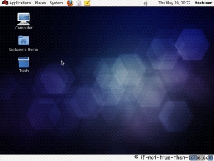

Accessing the Linux Machine:

We can access the Linux machine by using two users.

1. root user : We can call root as administrator user or super user. When we access the machine with root user, we can get # login prompt. root is having full permissions and access the machine and he can have full control over the system.
root user id is 0.

2. Normal user : When we login as normal user, we can we get the $ prompt and normal user is having limited permission to access the system.
Normal user’s userids will be start from 500.

Switching Between Users:

We can switch users by using su command.
$su root : switching user as root without changing his environment .
$su - root : switching user as root with new login environment.
$id : Print real and effective user and group IDs
Ex: $ id
uid=1001(yugandhar) gid=1001(yugandhar)
groups=1001(yugandhar),4(adm),27(sudo),108(lpadmin),124(sambashare)

The hyphen (-) has two effects:

1) switches from the current directory to the home directory of the new user (e.g., to /root in the case of the root user) by logging in as that user
2) changes the environmental variables to those of the new user as dictated by their ~/.bashrc. That is, if the first argument to su is a hyphen, the current directory and environment will be changed to what would be expected if the new user had actually logged on to a new session (rather than just taking over an existing session).
To open the terminal :

Applications -> System Tools -> Terminal.

- history : It is used for to see the history of the executed commands on the terminal.
#echo $HISTSIZE : We can see the history size
We can set the history size in the file .bashrc for user and /etc/bashrc is for entire system.

#echo $HISTFILE : It displays the history file size.

- <TAB> : tab key will complete you command while executing the commands.
Ex:- $ifco<tab> = $ifconfig

Getting Help:
There are few commands to help you about to know the commands.

- whatis - display one-line manual page descriptions (Short description of a command).
Syntax : $whatis <command>

Ex:- $ whatis date
date (1) - print or set the system date and time

- man - an interface to the on-line reference manuals.
man is the system's manual pager. Each page argument given to man is normally the name of a program, utility or function. The manual page associated with each of these arguments is then found and displayed.
The table below shows the section numbers of the manual followed by the types of pages they contain.

1 Executable programs or shell commands
2 System calls (functions provided by the kernel)
3 Library calls (functions within program libraries)
4 Special files (usually found in /dev)
5 File formats and conventions eg /etc/passwd
6 Games
7 Miscellaneous (including macro packages and conventions), e.g.
man(7), groff(7)
8 System administration commands (usually only for root)
9 Kernel routines [Non standard]

Syntax : $man <command>

Ex:- $man cal

- info : read info document.

Syntax: $info < command>

Ex:- $info date

- help: By using the help also, we can get the help about a command

Syntax:- $<command> --help

Ex:- $date --help

III.BASIC COMMANDS of Linux

pwd: The Linux pwd command show the name of the present working directory
Example:

[root@localhost bin]# pwd
/usr/bin
date: The Linux date command print or set the system date and time
Example:

[root@localhost bin]# date
Sat Dec 26 11:49:39 IST 2009

cal: Displays a calendar and the date of Easter

$ cal
January 2015
Su Mo Tu We Th Fr Sa
1 2 3
4 5 6 7 8 9 10
11 12 13 14 15 16 17
18 19 20 21 22 23 24
25 26 27 28 29 30 31
If you want see the complete year calendar,

Syntax: $cal 2015

If you want see the specific month of a particular year

$ cal oct 2015
October 2015
Su Mo Tu We Th Fr Sa
1 2 3
4 5 6 7 8 9 10
11 12 13 14 15 16 17
18 19 20 21 22 23 24
- 6 27 28 29 30 31

logname: Prints the login name of the current user.

# logname
root

whoami: The Linux "whoami" command displays who is the current user. Print the user name associated with the current effective user ID
Example:

[root@RHEL01 ~]# whoami
root

who am i : This command will let you who you are and logged in time.

# who am i
yugandhar pts/7 2015-01-19 15:23 (:0)

who: This command shows currently logged in users with time details

ex: # who
root tty1 2012-10-12 17:56 old 1960 (:0)
root pts/0 2012-10-12 17:57 06:51 2376 (:0.0)

w: To see who is currently logged in and what they are doing on your Linux/Unix-based server,
Sample outputs: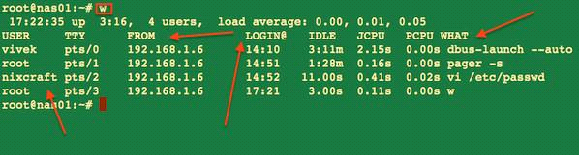

Finger :

The Linux finger command allows you to see who else is on the computer or get detailed information about a user who has access to the system.The following Linux finger command displays the who else are logged in on the computer currently.
[root@localhost ~]# finger
Login Name Tty Idle Login Time Office Office Phone
tintin tty3 Dec 27 12:20
The following Linux finger command displays detailed information about the user tintin.

[root@localhost ~]# finger tintin
Login: tintin Name: (null)
Directory: /home/tintin Shell: /bin/bash
Never logged in.
No mail.
No Plan.

Working with Files and Directories:

- touch command

touch:
The “touch” command stands for (Update the access and modification times of each FILE to the current time). touch command creates the file with zero byte size, only if it doesn’t exist. If the file already exists it will update the timestamp of a file.

Syntax : $touch <filename>

Ex: - $touch file1

- cat command

cat : The cat command displays the contents of a file
Note: “>>” and “>” are called append symbol. They are used to append the output to a file and not on standard output. “>” symbol will delete a file already existed and create a new file hence for security reason it is advised to use “>>” that will write the output without overwriting or deleting the file.

#cat > 1.txt
Hi my name is x .
I am friend of y
……….Ctrl + D
- ls command

$ls: list all the files and directories in current working directory

Option | Description
ls -a | list all files including hidden file starting with '.'
ls –color | colored list [=always/never/auto]
ls –d | list directories - with ' */'
ls –F | add one char of */=>@| to enteries
ls –i | list file's inode index number
ls -l | list with long format - show permissions
ls -la | list long format including hidden files
ls -lh | list long format with readable file size
ls -ls | list with long format with file size
ls -r | list in reverse order
ls -R | list recursively directory tree
ls -s | list file size
ls -S | sort by file size
ls -t | sort by time & date
ls –X | sort by extension name

Table: Options list of ls command

- rm command

rm: Linux command is used to remove/delete the file from the directory.the rm command can be used to remove one file, like this:

$rm oldfile.txt
You can also use the rm command to delete multiple Linux files at one time.

Ex: $rm file1 file2 file3
If you prefer to be careful when deleting files, use the -i option with the rm command. The -i stands for "inquire", so when you use this option the rm command prompts you with a yes/no prompt before actually deleting your files:

$rm -i files file2 file3

- mkdir command

mkdir: To create the directory

Syntax: $mkdir <Directory>

Ex: $mkdir DIR1

Ex: $mkdir -p DIR1/DIR2/DIR3

- rmdir command:

rmdir: To remove the empty directory

Syntax: $rmdir <Directory>

Ex: $rm -rf : To remove the directory which is having contents.

- cd command

cd: The Linux cd command can be used to change the working directory.
Examples:

[root@localhost ~]#cd /home (Changes the working directory to /home)

[root@localhost ~]#cd .. (Changes the working directory to the parent directory)

[root@localhost ~]#cd~(Changes the working directory to the users home directory)

- mv command

mv: The Linux mv command is used to move a file from one location to another location and renaming the file as well. Rename a File and Directory

Ex:[root@server02 ~]# mv file1 file2

[root@server02 ~]# mv dir1 dir2

Moving a file into some other location

Ex: [root@server02 ~]# mv file1 /tmp

- cp command

cp: copy files and directories
Syntax : $cp <source file> <dest file>
Ex: root@linux:~/test$ cp fire water

#cp –I

To prevent cp from overwriting existing files, use the -i (for interactive option)

#root@linux:~/test$ cp -i fire water
cp: overwrite `water'? no

#cp –r

To copy complete directories, use cp -r (the -r option forces recursive copying of all files in all subdirectories).

#root@linux:~/test$ cp -r MyDir MyDirB

To view the contents of a large files: more, less and pg

- more:

To view a text file one page at a time, press spacebar to go to the next page

$more filename : show the document one page at a time

$more -num filename : show the document page few lines as specified bu (-num)

example : more -10 filename will show 10 lines for every page

- less :

It is much the same as more command except:
You can navigate the page up/down using the less command and not possible in more command. You can search a string in less command. (use /keyword to search). “more” was fairly limited, and additional development on “more” had stopped. d) it uses same functions as vi editor the usage : less filename

- alias:

Invoking alias with no arguments will display all currently aliased commands.

Ex: $alias ls='ls --color=auto'

Creates the alias "ls" such that using the ls command will always display color output.

Ex: $alias ll='ls -la'

- tty:

The Linux "tty" command display the name of the connected terminal.

Example: [root@RHEL01 ~]# tty /dev/pts/0

Note: The above terminal displayed is a pseudo-terminal.

- which:

The Linux "which" command prints where in the search path an executable binary is located.

Example: [root@RHEL01 ~]# which mail /bin/mail

- echo:

The Linux "echo" command is used to print to the terminal.

Example 1: (Prints the given string to the terminal):

[root@RHEL01 ~]# echo "hell world"
hell world

Example 2 (Prints the variable $USER to the terminal):

[root@RHEL01 ~]# echo $USER
root

Example 3 (Prints the variable $PWD to the terminal):

[root@RHEL01 ~]# echo $PWD
/root

- clear: The Linux "clear" command clears the terminal.

- logout/exit: To logout from the current user.

Ex: $logout or $exit

halt, power off, and reboot are commands you can run as root to stop the system hardware.
halt instructs the hardware to stop all CPU functions.
power off sends an ACPI signal which instructs the system to power down.
reboot instructs the system to reboot.

- shutdown:

Shutdown the system in a safe way. You can shutdown the machine immediately, or schedule a shutdown using 24 hour format.

#shutdown 8:00

Schedule the system to shut down at 8 A.M.

#shutdown 20:00

Schedule the system to shut down at 8 P.M.

#shutdown +15 "Upgrading hardware, downtime should be minimal"

Schedule the system to shut down in fifteen minutes. Along with the normal message alerting users that the system is shutting down, they will be given the descriptive message about a hardware upgrade.

#shutdown now

Bring down the system immediately.

#shutdown -r now

Bring down the system immediately, and automatically reboot it.

#shutdown -P now

Bring down the system immediately, and automatically power off the system.

IV. Text Processing Tools (Utilities)

- wc:

wc (word count) command in Unix/Linux operating systems is used to find out number of newline count, word count, byte and characters count in a files specified by the file arguments. The syntax of wc command as shown below.
Syntax:# wc [options] filenames
The following are the options and usage provided by the command.

wc -l : Prints the number of lines in a file.
wc -w : prints the number of words in a file.
wc -c : Displays the count of bytes in a file.
- wc -m :

prints the count of characters from a file.

- Piping:

Now we'll take a look at a mechanism for sending data from one program to another. It's called piping and the operator we use is ( | ) (found above the backslash ( \ ) key on most keyboards). What this operator does is feed the output from the program on the left as input to the program on the right. In the example below we will list only the first 3 files in the directory. Ex:$ls
barry.txt bob example.png firstfile foo1 myoutput video.mpeg

$ls | head -3
barry.txt
bob
example.png

We may pipe as many programs together as we like. In the below example we have then piped the output to tail so as to get only the third file.

Ex:$ls | head -3 | tail -1
example.png

$ls /etc | wc -l
48

I/O Redirection:

we will explore a powerful feature used by many command line programs called input/output redirection. As we have seen, many commands such as ls print their output on the display. This does not have to be the case, however. By using some special notation we can redirect the output of many commands to files, devices, and even to the input of other commands.

Every program we run on the command line automatically has three data streams connected to it.
- STDIN (0) - Standard input (data fed into the program)
- STDOUT (1) - Standard output (data printed by the program, defaults to the terminal)
- STDERR (2) - Standard error (for error messages, also defaults to the terminal)
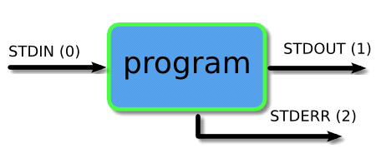
Piping and redirection is the means by which we may connect these streams between programs and files to direct data in interesting and useful ways. We'll demonstrate piping and redirection below with several examples but these mechanisms will work with every program on the command line, not just the ones we have used in the examples.
1 : Output Redirection:
Output Redirection is most commonly used, when you execute a command it’s normally appears on your terminal. Using this operator ‘>’ in shell you can redirect your output in a file.
Ex:
[root@loadb1/]#ls > output.txt

[root@loadb1/]#cat output.txt
bin
boot

Note: If output.txt file is already exit then ‘>’ operator will overwrite the file for append more output into output.txt use ‘>>’ instead of ‘>’.

2: Input Redirection:
You can redirect your input by using ‘<‘ operator. You cannot run input redirection on all programs or commands. you can use only with that programs or commands that accept Input from keyboard.
Example : you are going to send an email and u already have Template of that email. you can put your template in your email body using input redirect.
[root@loadb1 /]# mail ali < mail_template.txt
above command launch email program with mail_template.txt contents.
Now due to advancement in GUI, and also lots of good email clients, method is rarely used.
3 : Error Redirection:
Error Redirection is very helpful when u are in trouble. In my case i am trying to open a file that is not readable for my user i will get permission denied errors. i will redirect these error into error.txt file.
Example :

[H.Ali@lx1/]$cat ali.txt 2> /home/H.Ali/error.txt
[H.Ali@lx1 /]$ cat /home/H.Ali/error.txt
cat: ali.txt: Permission denied
In the above command 2 is descriptor of error redirection file by typing ‘2>’ you are saying redirect any kind of error to the file error.txt
Redirecting the standard error (stderr) and stdout to file
Use the following syntax:

$ command-name &>file

OR

$ command > file-name 2>&1
Another useful example:

# find /usr/home -name .profile 2>&1 | more
Redirecting both STDERROR & STDOUT to a file
Syntax: $command &> file1.txt

Ex:- ls /etc &> file1.txt

- tee :

Tee redirects standard input to both standard output and one or more files.

$command | tee file

This pattern (which includes the tee command) redirects the standard output of the command to a file and overwrites its contents. Then, it displays the redirected output in the terminal. It creates a new file if the file does not already exist. In the context of this pattern, tee is typically used to view a program's output while simultaneously saving it to a file.

$wc /etc/magic | tee magic_count.txt
Examples

#ls -1 *.txt | wc -l | tee count.txt

In the above example, the ls command lists all files in the current directory that have the filename extension .txt, one file per line; this output is piped to wc, which counts the lines and outputs the number; this output is piped to tee, which writes the output to the terminal, and writes the same information to the file count.txt. If count.txt already exists, it is overwritten.
- grep command:
The basic usage of grep command is to search for a specific string in the specified file as shown below.
Syntax: grep "literal_string" filename

$ grep "this" demo file

this line is the 1st lower case line in this file.
Two lines above this line is empty.

Another definition for grep:

grep prints lines of input matching a specified pattern.

Syntax: grep [OPTIONS] PATTERN [FILE...]

#grep chope /etc/passwd
Search /etc/passwd for user chope.

#grep -r "computerhope" /www/

Recursively search the directory /www/, and all subdirectories, for any lines of any files which contain the string "computerhope".

#grep -w "hope" myfile.txt

Search the file myfile.txt for lines containing the word "hope". Only lines containing the distinct word "hope" will be matched. Lines in which "hope" is part of a word will not be matched.

#grep -cw "hope" myfile.txt

Same as previous command, but displays a count of how many lines were matched, rather than the matching lines themselves.

#grep -cvw "hope" myfile.txt

Inverse of previous command: displays a count of the lines in myfile.txt which do not contain the word "hope".

#grep -l "hope" /www/*

Display the filenames (but not the matching lines themselves) of any files in /www/ (but not its subdirectories) whose contents include the string "hope".

Egrep :
egrep (grep -E in linux) is extended grep where additional regular expression metacharacters have been added like +, ?, | and ().
Ex:- ls | egrep ' .txt|.php'
Fgrep :
fgrep (grep -F in linux) is fixed or fast grep and behaves as grep but does not recognise any regular expression meta characters as being special.
Ex:-fgrep'forum'file1.txt

- cut command:
Cut command in Unix (or Linux) is used to select sections of text from each line of files. You can use the cut command to select fields or columns from a line by specifying a delimiter or you can select a portion of text by specifying the range or characters. Basically the cut command slices a line and extracts the text

syntax : cut [option] [source file]

[root@server02 ~]# cat file1
Hi Flashsoftindia
Welcome you guys

[root@server02 ~]# cut -c1-5 file1
Hi Fl
Welcome

[root@server02 ~]# cut -d":" -f 1 /etc/passwd
root
bin
daemon
adm

[root@server02 ~]# cut -d":" -f1,5 /etc/passwd
root: root
bin: bin
daemon: daemon
- sort command:

Sort command in unix or linux system is used to order the elements or text. Sort command has the capability of sorting numerical values and strings. The sort command can order the lines in a text file.

syntax : sort [options] filename
The options are:
-b : Ignores leading spaces in each line
-d : Uses dictionary sort order. Conisders only spaces and alphanumeric characters in sorting
-f : Uses case insensitive sorting.
-M : Sorts based on months. Considers only first 3 letters as month. Eg: JAN, FEB
-n : Uses numeric sorting
-R : Sorts the input file randomly.
-r : Reverse order sorting
-k : Sorts file based on the data in the specified field positions.
-u : Suppresses duplicate lines
-t : input field separator
File with Ascii data:
Let us consider a file with the following contents:

$ cat file
Unix
Linux
Solaris
AIX
Linux
HPUX
sort simply sorts the file in alphabetical order:
$ sort file
AIX
HPUX
Linux
Linux
Solaris
Unix

sort file on the basis of 1st field:

$ sort -t"," -k1,1 file
\AIX,25
HPUX,100
Linux,20
Linux,25
Solaris,10

$ sort –O resultfile file1 file2

This command sorts the file1 and file2 and store the result in resultfile.
- uniq:
Uniq command in unix or linux system is used to suppress the duplicate lines from a file. It discards all the successive identical lines except one from the input and writes the output. The default behavior of the uniq command is to suppress the duplicate line. Note that, you have to pass sorted input to the uniq, as it compares only successive lines.

> uniq example.txt
Unix operating system
Unix dedicated server
Linux dedicated server
If the lines in the file are not in sorted order, then use the sort command and then pipe the output to the uniq command.

> sort example.txt | uniq

Count of lines.
The -c option is used to find how many times each line occurs in the file. It prefixes each line with the count.

$uniq -c example.txt
2 Unix operating system
1 Unix dedicated server
1 Linux dedicated server
3. Display only duplicate lines.
You can print only the lines that occur more than once in a file using the -d option.

$ uniq -d example.txt
Unix operating system
$uniq -D example.txt
Unix operating system
Unix operating system

- Translate command :

tr stands for translate or transliterate. The tr utility in Unix or Linux system is used to translate, delete or squeeze characters. The syntax of tr command is

$tr [options] set1 [set2]
The options of tr command are:
-c : complements the set of characters in string.
-d : deletes the characters in set1
-s : replaces repeated characters listed in the set1 with single occurrence
-t : truncates set1
Tr command Examples:
1. Convert lower case letters to upper case
The following tr command translates the lower case letters to capital letters in the give string:

$echo "Linux dedicated server" | tr "[:lower:]" "[:upper:]"
LINUX DEDICATED SERVER
$echo "Linux dedicated server" | tr "[a-z]" "[A-Z]"
- Comparing Files: diff is used to compare the contents of two files of differences.

Syntax : diff <file1> <file2>

[root@server02 ~]# cat file1
Hello Welcome to india

[root@server02 ~]# cat file2
Hello Welcome to flashsoftindia
It is incredible in ATP

[root@server02 ~]# diff file1 file2
1c1,2
< Hello Welcome to india
---
> Hello Welcome to flashsoftindia
> It is incredible in ATP

[root@server02 ~]#

Patch : Patch duplicates changes in other files.
-b option to automatically back up changed files.

[root@server02 ~]# diff -u file1 file2 > file.patch

[root@server02 ~]# patch -b file1 file.patch
patching file file1

[root@server02 ~]# cat file1
Hello Welcome to flashsoftindia
It is incredible in ATP

[root@server02 ~]# cat file2
Hello Welcome to flashsoftindia
It is incredible in ATP
- sed command:
Sed is a Stream Editor used for modifying the files in unix (or linux). Whenever you want to make changes to the file automatically, sed comes in handy to do this. Most people never learn its power; they just simply use sed to replace text. You can do many things apart from replacing text with sed.

$cat file.txt
Unix is great os. Unix is open source. Unix is free os.
learn operating system.
Unix Linux which one you choose.
Replacing or substituting string

$sed 's/Unix/Linux/' file.txt
Linux is great os. Unix is open source. Unix is free os.
learn operating system.
Linux Linux which one you choose.
Replacing the nth occurrence of a pattern in a line.

$sed 's/Unix/Linux/2' file.txt
Unix is great os. Linux is open source. Unix is free os.
learn operating system.
Unix Linux which one you choose.
Replacing all the occurrence of the pattern in a line

$sed 's/Unix/Linux/g' file.txt
Linux is great os. Linux is open source. Linux is free os.
learn operating system.
Linux Linux which one you choose.
Duplicating the replaced line with /p flag

$sed 's/Unix/Linux/p' file.txt
Linux is great os. Unix is open source. Unix is free os.
Linux is great os. Unix is open source. Unix is free os.
learn operating system.
Linux Linux which one you choose.
Linux Linux which one you choose.
Deleting lines

$sed '2 d' file.txt
$sed '5,$ d' file.txt
- head command:
head, by default, prints the first 10 lines of each FILE to standard output. With more than one FILE, it precedes each set of output with a header identifying the file name. If no FILE is specified, or when FILE is specified as a dash ("-"), head reads from standard input.

[root@server02 ~]# head /etc/passwd
root:x:0:0:root:/root:/bin/bash
bin:x:1:1:bin:/bin:/sbin/nologin
daemon:x:2:2:daemon:/sbin:/sbin/nologin
adm:x:3:4:adm:/var/adm:/sbin/nologin
lp:x:4:7:lp:/var/spool/lpd:/sbin/nologin
sync:x:5:0:sync:/sbin:/bin/sync
shutdown:x:6:0:shutdown:/sbin:/sbin/shutdown
halt:x:7:0:halt:/sbin:/sbin/halt
mail:x:8:12:mail:/var/spool/mail:/sbin/nologin
uucp:x:10:14:uucp:/var/spool/uucp:/sbin/nologin

[root@server02 ~]# head -n 15 /etc/passwd
root:x:0:0:root:/root:/bin/bash
bin:x:1:1:bin:/bin:/sbin/nologin
daemon:x:2:2:daemon:/sbin:/sbin/nologin
adm:x:3:4:adm:/var/adm:/sbin/nologin
lp:x:4:7:lp:/var/spool/lpd:/sbin/nologin
sync:x:5:0:sync:/sbin:/bin/sync
shutdown:x:6:0:shutdown:/sbin:/sbin/shutdown
halt:x:7:0:halt:/sbin:/sbin/halt
mail:x:8:12:mail:/var/spool/mail:/sbin/nologin
uucp:x:10:14:uucp:/var/spool/uucp:/sbin/nologin
operator:x:11:0:operator:/root:/sbin/nologin
games:x:12:100:games:/usr/games:/sbin/nologin
gopher:x:13:30:gopher:/var/gopher:/sbin/nologin
ftp:x:14:50:FTP User:/var/ftp:/sbin/nologin
nobody:x:99:99:Nobody:/:/sbin/nologin
- tail command:
tail prints the last 10 lines of each FILE to standard output. With more than one FILE, it precedes each set of output with a header giving the file name. If no FILE is specified, or if FILE is specified as a dash ("-"), tail reads from standard input.

[root@server02 ~]# tail /etc/passwd
ntp:x:38:38::/etc/ntp:/sbin/nologin
saslauth:x:499:76:"Saslauthd user":/var/empty/saslauth:/sbin/nologin
postfix:x:89:89::/var/spool/postfix:/sbin/nologin
rpcuser:x:29:29:RPC Service User:/var/lib/nfs:/sbin/nologin
nfsnobody:x:65534:65534:Anonymous NFS User:/var/lib/nfs:/sbin/nologin
sshd:x:74:74:Privilege-separated SSH:/var/empty/sshd:/sbin/nologin
tcpdump:x:72:72::/:/sbin/nologin
oprofile:x:16:16:Special user account to be used by OProfile:/home/oprofile:/sbin/nologin
nag:x:500:500::/home/nag:/bin/bash
nagesh:x:501:501::/home/nagesh:/bin/bash

[root@server02 ~]# tail -n 15 /etc/passwd
dbus:x:81:81:System message bus:/:/sbin/nologin
vcsa:x:69:69:virtual console memory owner:/dev:/sbin/nologin
rpc:x:32:32:Rpcbind Daemon:/var/cache/rpcbind:/sbin/nologin
abrt:x:173:173::/etc/abrt:/sbin/nologin
haldaemon:x:68:68:HAL daemon:/:/sbin/nologin
ntp:x:38:38::/etc/ntp:/sbin/nologin
saslauth:x:499:76:"Saslauthd user":/var/empty/saslauth:/sbin/nologin
postfix:x:89:89::/var/spool/postfix:/sbin/nologin
rpcuser:x:29:29:RPC Service User:/var/lib/nfs:/sbin/nologin
nfsnobody:x:65534:65534:Anonymous NFS User:/var/lib/nfs:/sbin/nologin
sshd:x:74:74:Privilege-separated SSH:/var/empty/sshd:/sbin/nologin
tcpdump:x:72:72::/:/sbin/nologin
oprofile:x:16:16:Special user account to be used by OProfile:/home/oprofile:/sbin/nologin
nag:x:500:500::/home/nag:/bin/bash
nagesh:x:501:501::/home/nagesh:/bin/bash

$tail -f myfile.txt : Outputs the last 10 lines of myfile.txt, and monitors myfile.txt for updates; tail then continues to output any new lines that are added to myfile.txt.
[root@server02 ~]# tail -f /var/log/messages
Jan 19 17:35:02 server02 rsyslogd: [origin software="rsyslogd" swVersion="5.8.10" x-pid="1007" x-info="http://www.rsyslog.com"] rsyslogd was HUPed

- Zipping the Files:

Compressed files occupy less disk space and download faster than large, uncompressed files. You can compress Linux files with the open-source compression tool gzip and decompress the compressed files using gzip or gunzip tool. The Linux gzip tool reduces the size of the files using Lempel-Ziv coding (LZ77).
gzip/gunzip/zcat

You can compress a file using gzip by the following commands. The first command will create a compressed gzip file with gz extension, removing the uncompressed file and second command will create a compressed gzip file with gz extension keeping the uncompressed file. The Linux zcat command allows the user to expand and view a compressed file without uncompressing that file.

[root@RHEL2 gzip]# gzip gzip.txt

Or

[root@RHEL2 gzip]# gzip -c gzip.txt > gzip.txt.gz
And decompress the compressed file using the following command

[root@RHEL2 gzip]# gzip -d gzip.txt.gz
A compressed file can also decompressed by using gunzip command as shown below.

[root@RHEL2 gzip]# gunzip gzip.txt.gz
To list the compressed file information, use “gzip –l” option.

[root@RHEL2 gzip]# gzip -l gzip.txt.gz
To view a compressed file, without uncompressing it, you can use the zcat file as shown below.

[root@localhost ~]# zcat gzip.txt.gz
This is a test...
Hello Dear Guys,
Welcome to flash soft india

Compressed files occupy less disk space and download faster than large, uncompressed files. The Linux bzip2 command has better compression ratio compared with Linux gzip command. To create a compressed file using Linux bzip2 command, use the following command. The first command will create a compressed bzip2 file with bz2 extension, removing the uncompressed file and second command will create a compressed bzip2 file with bz2 extension keeping the uncompressed file.

[root@RHEL2 bzip2]# bzip2 bzip2.txt

OR

[root@RHEL2 bzip2]# bzip2 -c bzip2.txt > bzip2.txt.bz2
To decompress the bzip2 compressed file, use the “bzip2 –d” option.

[root@RHEL2 bzip2]# bzip2 -d bzip2.txt.bz2
If you want only to read the compressed file without uncompressing it, use the bzcat command as shown below.

[root@localhost ~]# bzcat bzip2.txt.bz2
This is a test...
Hello Dear Guys,
Welcome to Flashsoftindia
…………………………………………………

- tar (tape archiving) command:
The tar program is used to create, maintain, modify, and extract files that are archived in the tar format.

#tar cf archive.tar file1 file2
Create archive archive.tar containing files file1 and file2. Here, the c tells tar you will be creating an archive; the f tells tar that the next option (here it's archive.tar) will be the name of the archive it creates. file1 and file2, the final arguments, are the files to be archived.

#tar xf archive.tar
Extract the files from archive archive.tar. x tells tar to extract files from an archive; f tells tar that the next argument will be the name of the archive to operate on.

#tar xzvf archive.tar.gz
Extract the files from gzipped archive archive.tar.gz verbosely. Here, the z tells tar that the archive will be compressed with gzip.

#tar czf archive.tar.gz mydir/
Creates an gzip-compressed archive of the directory mydir.

#tar xvf archive.tar documents/work/budget.doc
Extract only the file documents/work/budget.doc from the archive archive.tar. Produce verbose output.

#tar xvf archive.tar --wildcards '*.doc'

Extract only files with the extension .doc from the archive archive.tar. The --wildcards option tells tar to interpret wildcards in the name of the files to be extracted; the filename (*.doc) is enclosed in single-quotes to protect the wildcard (*) from being expanded incorrectly by the shell.

#tar uvf archive.tar documents/work/budget.doc

Add the file documents/work/budget.doc to the archive archive.tar only if it is newer than the version already in the archive (or does not yet exist in the archive). Here, u is the same as the long option --update.

Finding Files in Linux:

- find :

The find command is used to locate files on a Unix or Linux system. find will search any set of directories you specify for files that match the supplied search criteria. You can search for files by name, owner, group, type, permissions, date, and other criteria. The search is recursive in that it will search all subdirectories too.

The syntax looks like this: $find where-to-look criteria what-to-do
basic 'find file' commands
--------------------------
find / -name foo.txt -type f -print # full command
find / -name foo.txt -type f # -print isn't necessary
find / -name foo.txt # don't have to specify "type==file"
find . -name foo.txt # search under the current dir
find . -name "foo.*" # wildcard
find . -name "*.txt" # wildcard
find /users/al -name Cookbook -type d # search '/users/al'
search multiple dirs
--------------------
find /opt /usr /var -name foo.scala -type f # search multiple dirs
case-insensitive searching
--------------------------
find . -iname foo # find foo, Foo, FOo, FOO, etc.
find . -iname foo -type d # same thing, but only dirs
find . -iname foo -type f # same thing, but only files
find files with different extensions
------------------------------------
find . -type f \( -name "*.c" -o -name "*.sh" \) # *.c and *.sh files
find . -type f \( -name "*cache" -o -name "*xml" -o -name "*html" \) # three patterns
find files that don't match a pattern (-not)
--------------------------------------------
find . -type f -not -name "*.html" # find all files not ending in ".html"
find files by text in the file (find + grep)
--------------------------------------------
find . -type f -name "*.java" -exec grep -l StringBuffer {} \; # find StringBuffer in all *.java files
find . -type f -name "*.java" -exec grep -il string {} \; # ignore case with -i option
find . -type f -name "*.gz" -exec zgrep 'GET /foo' {} \; # search for a string in gzip'd files
5 lines before, 10 lines after grep matches
-------------------------------------------
find . -type f -name "*.scala" -exec grep -B5 -A10 'null' {} \;
find files and act on them (find + exec)
----------------------------------------
find /usr/local -name "*.html" -type f -exec chmod 644 {} \; # change html files to mode 644
find htdocs cgi-bin -name "*.cgi" -type f -exec chmod 755 {} \; # change cgi files to mode 755
find . -name "*.pl" -exec ls -ld {} \; # run ls command on files found
find and copy
-------------
find . -type f -name "*.mp3" -exec cp {} /tmp/MusicFiles \; # cp *.mp3 files to /tmp/MusicFiles
copy one file to many dirs
--------------------------
find dir1 dir2 dir3 dir4 -type d -exec cp header.shtml {} \; # copy the file header.shtml to those dirs
find and delete
---------------
find . -type f -name "Foo*" -exec rm {} \; # remove all "Foo*" files under current dir
find . -type d -name CVS -exec rm -r {} \; # remove all subdirectories named "CVS" under current dir
find files by modification time
-------------------------------
find . -mtime 1 # 24 hours
find . -mtime -7 # last 7 days
find . -mtime -7 -type f # just files
find . -mtime -7 -type d # just dirs
find files by modification time using a temp file
-------------------------------------------------
touch 09301330 poop # 1) create a temp file with a specific timestamp
find . -mnewer poop # 2) returns a list of new files
rm poop # 3) rm the temp file
find with time: this works on mac os x
--------------------------------------
find / -newerct '1 minute ago' -print
find and tar
------------
find . -type f -name "*.java" | xargs tar cvf myfile.tar
find . -type f -name "*.java" | xargs tar rvf myfile.tar
find, tar, and xargs
--------------------
find . -name -type f '*.mp3' -mtime -180 -print0 | xargs -0 tar rvf music.tar
find and pax (instead of xargs and tar)
---------------------------------------
find . -type f -name "*html" | xargs tar cvf jw-htmlfiles.tar -
find . -type f -name "*html" | pax -w -f jw-htmlfiles.tar
V. Basic Linux Networking Tools

Hostname and FQDN Settings :

To set your system’s hostname and FQDN (fully qualified domain name). Your hostname should be something unique; Please note that the system’s hostname has no relationship to websites or email services hosted on it, aside from providing a name for the system itself. Thus, your hostname should not be “www” or anything else too generic.

$hostname : It is the command to get the hostname

$hostname <sys01.flash.com> : To set up the hostname temporarily

Red Hat based system use the file /etc/sysconfig/network to read the saved hostname at system boot. This is set using the init script /etc/rc.d/rc.sysinit

$cat /etc/sysconfig/network
NETWORKING=yes
HOSTNAME="sys01.flash.com"

Setting up the network parameters in Linux

To configure static ip address, default gateway, netmask, dns server and make a network auto start at boot on Linux host normally configured with static ip address, so that easier to maintain the configuration on its client and DNS server will always able to resolve it. See below the default RHEL/Centos, network card configuration file.
# cat /etc/sysconfig/network-scripts/ifcfg-eth0
DEVICE="eth0"
BOOTPROTO="dhcp"
HWADDR="xx:xx:xx:xx:xx:xx"
NM_CONTROLLED="yes"
ONBOOT="no"
TYPE="Ethernet"
DEVICE: Specifies the device to use for the configuration.
IPADDR: The static IP for the network interface
NETMASK: The network mask for the device
HWADDR: The MAC address for the device
NM_CONTROLLED: Determines if the device can be controlled by the network manager.
ONBOOT: Determines if the device should be initialized when booted
DNS1: Specifies the DNS server for the device. This is needed for name resolution. You may also add DNS2 and DNS3 if you have additional servers.

Here are steps to configure static ip address and auto start of network card once system rebooted.

# vi /etc/sysconfig/network-scripts/ifcfg-eth0
DEVICE="eth0"
BOOTPROTO="static"
HWADDR="xx:xx:xx:xx:xx:xx"
NM_CONTROLLED="yes"
ONBOOT="yes"
TYPE="Ethernet"
IPADDR=192.168.1.2
NETMASK=255.255.255.0

Configure the gateway

# vi /etc/sysconfig/network
NETWORKING=yes
HOSTNAME=host.lintut.com
GATEWAY=192.168.1.1

Configure the DNS resolver

# vi /etc/resolv.conf
nameserver 8.8.8.8
nameserver 8.8.4.4

Restart Network service:

# service network restart
To Set up the IP address temporarily

We can assign the ip, netmask, gateway in one command

$ifconfig eth0 192.168.0.1 netmask 255.255.255.0 gw 192.168.0.254

Local Resolver: If we don’t have a DNS server in our infrastructure, we can define all hostnames in the Local Resolver files (/etc/hosts).

The main purpose of /etc/hosts configuration file is to resolve hostnames that cannot be resolved any other way. It can also be used to resolve hostnames on small networks with no DNS server. Regardless of the type of network the computer is on, this file should contain a line specifying the IP address of the loopback device (127.0.0.1) as localhost.localdomain.

$ cat /etc/hosts
127.0.0.1 dev-server localhost.localdomain localhost

$ cat /etc/hosts
127.0.0.1 prod-server localhost.localdomain localhost

Diagnostics of Network:

ping is a simple way to send network data to, and receive network data from, another computer on a network. It is frequently used to test, at the most basic level, whether another system is reachable over a network, and if so, how much time it takes for that data to be exchanged.

Network Clients:

ELINKS:

ELinks is a text mode WWW browser, supporting colors, table rendering, background downloading, menu driven configuration interface, tabbed browsing and slim code. ELinks can handle both local files and remote URLs. The main supported remote URL protocols are HTTP, HTTPS (with SSL support compiled in) and FTP. Additional protocol support exists for BitTorrent finger, Gopher, SMB and NNTP.

$links http://www.google.com

wget:

wget is a free utility for non-interactive download of files from the web. It supports HTTP, HTTPS, and FTP protocols, as well as retrieval through HTTP proxies.

Ex: #wget http://website.com/files/file.zip

scp:

The scp tool is used to copy files from one computer to another while encrypting the data.

Example 1 – Below command will copy myfile.txt securely to a remote machine:

[root@RHEL04 ~]# scp myfile.txt tintin@192.168.1.106:
The authenticity of host '192.168.1.106 (192.168.1.106)' can't be established.
RSA key fingerprint is 88:8e:46:35:ac:dc:5e:73:f2:ce:9a:29:41:f5:73:fb.
Are you sure you want to continue connecting (yes/no)? yes
Warning: Permanently added '192.168.1.106' (RSA) to the list of known hosts.
tintin@192.168.1.106's password:
myfile.txt 100% 48KB 47.9KB/s 00:00
Example 2 – Below command will copy mynewfile.txt securely from a remote machine to your machine:

[root@RHEL04 ~]# scp tintin@192.168.1.106:mynewfile.txt mylocalfile.txt
tintin@192.168.1.106's password:
mynewfile.txt 100% 575KB 575.1KB/s 00:00
Note: To see more details about the status of command, use the verbose mode (-v).

- RSYNC:

Rsync (Remote Sync) is a most commonly used command for copying and synchronizing files and directories remotely as well as locally in Linux/Unix systems. With the help of rsync command you can copy and synchronize your data remotely and locally across directories, across disks and networks, perform data backups and mirroring between two Linux machines.

#rsync -avR /foo/bar/baz.c remote:/tmp/
then a file named /tmp/foo/bar/baz.c would be created on the remote machine, preserving its full path. These extra path elements are called "implied directories" (i.e. the "foo" and the "foo/bar" directories in the above example).

Vi/Vim Command Line Arguments:
Command usage: vim [arguments] filename1 [filename2 ...]
Vim arguments are listed in this table:
Arguments | Description
+[num] | Open editor with cursor on line "num". If "num" is not specified, the cursor will be on the last line of the file.
+/{pat} | Open editor with cursor on the first occurrence of {pat}.
-c {command}  --cmd {command} | A "ex" command in dowble quotes will be processed against the file specified.
-b | Binary file mode.
-C  -v | VI compatibility mode. Loses the more advanced vim features.
-d | Diff file mode. Must list all files to perform a diff upon (list 2, 3 or 4 files). Same as vimdiff.
-g | GUI gvim mode (if compiled in and available).
-h  --help | Print help messages. Also see vimtutor
-i filename | Specify viminfo file. Default is ~/.viminfo
-r  -L | Recovery mode. Used after a crash. The ".swp" file is used. See ":help recovery".
-M  -R | File modifications and write not allowed.
-n | Prohibit ".swp" file generation. Required for special devices of limited space.
-x | Use encryption when writing files. Will prompt for a crypt key.
--noplugin | Skip loading plugins.
--version | Print vim version.
Basic "vi" features:
One edits a file in vi by issuing the command: vi file-to-edit.txt
The vi editor has three modes, command mode, insert mode and command line mode.
- Command mode: letters or sequence of letters interactively command vi. Commands are case sensitive. The ESC key can end a command.
- Insert mode: Text is inserted. The ESC key ends insert mode and returns you to command mode. One can enter insert mode with the "i" (insert), "a" (insert after), "A" (insert at end of line), "o" (open new line after current line) or "O" (Open line above current line) commands.
- Command line mode: One enters this mode by typing ":" which puts the command line entry at the foot of the screen.
Partial list of interactive commands:
Cursor Movement Commands:
Keystrokes | Action
h/j/k/l | Move cursor left/down/up/right
spacebar | Move cursor right one space
-/+ | Move cursor down/up in first column
ctrl-d  n ctrl-d | Scroll down one half of a screen.  Set scroll to "n" lines. New default set for half screen.
ctrl-u  n ctrl-u | Scroll up one half of a screen  Set scroll to "n" lines. New default set for half screen.
ctrl-f  n ctrl-f | Scroll forward one screen  Scroll forward "n" screen
ctrl-b  n ctrl-b | Scroll back one screen  Scroll back "n" screen
ctrl-y  n ctrl-y | Scroll forward one line  Scroll forward "n" lines
ctrl-e  n ctrl-e | Scroll back one line  Scroll back "n" lines
M (shift-m) | Move cursor to middle of page
H (shift-h) | Move cursor to top of page
L (shift-l) | Move cursor to bottom of page
W  w  5w | Move cursor a word at a time (white space delimited)  Move cursor a word at a time (first non-alphanumeric)  Move cursor ahead 5 words
B  b  5b | Move cursor back a word at a time (white space delimited)  Move cursor back a word at a time (first non-alphanumeric)  Move cursor back 5 words
E  e  5e | Move cursor to end of word (white space delimited)  Move cursor to end of word (first non-alphanumeric)  Move cursor ahead to the end of the 5th word
0 (zero) | Move cursor to beginning of line
:30 | Move cursor to line thirty
$ | Move cursor to end of line
) | Move cursor to beginning of next sentence (delimeted by ".", "?" or "!")
( | Move cursor to beginning of current sentence
} | Move cursor to beginning of next paragraph (delimeted by blank line or nroff macros: .IP, .LP, .PP, .QP, .P, .LI and .bp) Also see "set paragraphs" to define a paragraph.
{ | Move cursor to beginning of current paragraph
]] | Move cursor to beginning of next section (delimeted by nroff macros: .NH, .SH, .H, .HU). Also see "set sections" to define a section.
[[ | Move cursor to beginning of current section
G | Move cursor to end of file
% | Move cursor to the matching bracket.  Place cursor on {}[]() and type "%".  Use the matchit or xmledit plug-in to extend this capability to XML/XHTML tags.
'. | Move cursor to previously modified line.
m  ma | Mark the line on which the cursor resides. Marking requires an identifier.  Mark the line as identified by the letter "a" by marking with keystroke "ma"
'a | Move cursor to line mark "a" generated by marking with keystroke "ma"
'A | Move cursor to line mark "A" (global between buffers) generated by marking with keystroke "mA"
]' | Move cursor to next lower case mark.
[' | Move cursor to previous lower case mark.
Editing Commands:
Keystrokes | Action
i | Insert at cursor. Puts you in insert mode. Must use esc key to terminate insert mode.
I | Insert before the cursor. Puts you in insert mode. Must use esc key to terminate insert mode.
a | Append after cursor. Puts you in insert mode. Must use esc key to terminate insert mode.
A | Append at end of line. Puts you in insert mode. Must use esc key to terminate insert mode.
o | Open a new line below the current cursor position. Also puts you in insert mode. Must use esc key to terminate insert mode.
O | Open a new line above the current line. Also puts you in insert mode. Must use esc key to terminate insert mode.
ESC | Terminate insert mode. Terminates most other modes as well.
u | Undo last change
U | Undo all changes to entire line
dd  3dd | Delete line (stored in local buffer)  Delete 3 lines (stored in local buffer).
D | Delete contents of line after cursor
C | Delete contents of line after cursor and insert new text. Press esc key to end insertion.
dw  4dw  d)  d$  d-  dfx  d'x  'ad'b  d/cat | Delete word  Delete 4 words  Delete to end of sentence  Delete all characters from cursor to end of line  Delete current and previous line  Delete from cursor to first occurance of the letter "x"  Delete from the current line to the line marked with the identifier "x"  Delete from the line of mark "a" to the line marked "b".  Delete all characters from the cursor to the next occurance of (but not including) "cat"
cw  c)  c$ | Change word  Change sentence  Change from cursor to end of line  (See "d" delete above for other variations)
x | Delete character at cursor
X | Delete character before cursor
Y  or  yy | Yank (copy) current line into "unnamed" storage buffer.
p | Paste unnamed storage buffer after current line.
P | Paste unnamed storage buffer before current line.
r | Replace character
R | Overwrite characters from cursor onward
s | Substitute one character under cursor continue to insert
S | Substitute entire line and begin to insert at beginning of line
J | Join current and following line into one line
~ | Change case of individual character
ctrl-a  ctrl-x | Increment number under the cursor.  Decrement number under the cursor.
. | repeat last command action.
Control Characters: Note that to enter control characters while in insert mode, prefix the the control character with "ctrl-v" and then type the control character (ex. Carriage control: ctrl-M, Form feed: ctrl-L, Backspace: ctrl-H, Delete: ctrl-P, ...). Each control character must first be preceeded by ctrl-v while in insert mode.
Delete/Restore Buffers: Each time you delete or yank a line, it is stored in a local buffer and can be recalled and pasted. See "vi line buffers" examples below.
Search Commands:
Keystrokes | Action
/search_string{CR} | Search for search_string
?search_string{CR} | Search backwards (up in file) for search_string
/\<search_string\>{CR} | Search for search_word  Ex: /\<s\>  Search for variable "s" but ignore declaration "string" or words containing "s". This will find "string s;", "s = fn(x);", "x = fn(s);", etc
n | Find next occurrence of search_word
N | Find previous occurrence of search_word
fx  nfx  ; | Move cursor to first occurance of letter "x" after the cursor but in the same line  Move cursor to "n"th occurance of letter "x" in line  Go to next occurance in line
Fx  nFx  ; | Move cursor backwards to next occurance of letter "x" in line  Move cursor backwards to "n"th occurance of letter "x" in line  Go to previous occurance in line
tx  ntx  ; | Move cursor to one char before the next occurance of letter "x" in line  Move cursor to one char before the "n"th occurance of letter "x" in line.  Go to one char before the next occurance in line
Tx  nTx  ; | Move cursor backwards to one char before the next occurance of letter "x"  Move cursor backwards to one char before the "n"th occurance of letter "x"  Go to one char before previous occurance in line
Where search strings can have the following patterns:
Pattern | Description
. | A period matches any single character
^ | Finds the beginning of a line
^A | Finds the beginning of a line where the first character is the letter 'A'
$ | Matches the end of a line
[abc] | Matches a string which contains any of the letters (a, b or c) between the brackets
\ | Turn off the special meaning of a character. Example "\." does not match the period to any character but to the period character specifically
\d | Match any single digit (0 to 9)
* | A search expression followed by a '*' matches zero or more of the search expression. For example "A*" will match A, AA and AAA
+ | Same as '*' above except that it matches one or more of the search expression.
? | Same as '*' and "+" except that it matches zero or one occurances
string1|string2 | Match any either string 1 or string 2
a.b | Matches a string beginning with the letter 'a' followed by any character, again followed by the letter 'c'
^.$ | Matches an entire line containing only a single character
a(b*|c*)d | Matches a string beginning with the letter 'a' followed by zero or more of the letter 'b', followed by zero or more of the letter 'c' and then followed by the letter 'd'
Linux.*Linux | Finds a line containing two instances of the string "Linux"
.* [a-z]+ .* | Finds a line containing a word comprised of all lower case letters with a single blank on either side of the word

Information Commands:
Keystrokes | Action
ctrl-g  or  :f | List file info: fine name, number of lines in file, position of cursor in file.
:set list  :set nolist | Show tabs and end of line markers  Turn of tab and eol markings
:args | Show command line arguments used

Terminate session:
- Use command: ZZ
Save changes to current file and quit.
- Use command line: ":wq"
Save (write) changes to current file and quit.
- Use command line: ":w"
Save (write) changes to current file without quitting.
- Use command line: ":w!"
Save (write) changes to current file overriding the file permissions if the user has the privileges to change the file permissions. For example this will save a file with read only privileges if the user is the owner or has the ability to modify the privileges to allow a write. This will not permanently modify the file privileges. Note that there is no space between the two characters. A space will infer that the output is streamed to a Unix command following the "!".
- Use command line: ":w filename"
Save (write) changes to a new file of name "filename" without quitting.
- Use command line: ":q!"
Ignore changes and quit. No changes from last write will be saved.
- Use command line: ":qa"
Quit all files opened.
New session:
- Use command: ":e filename"
Start new edit session on specified file name without closing current vi / vim editor process.

Vi/Vim modes:
Vi/Vim modes are set using the "set" command and its many options.
:set all - display all mode settings of your editing session.
:set termcap - display terminal settings of your editing session.
:set ic - Change default to ignore case for text searches
Default is changed from noignorecase to ignorecase. (ic is a short form otherwise type set ignorecase)
Common options to set:
Full "set" Command | Short form | Description
:set autoindent  :set noautoindent | :set ai  :set noai | {CR} returns to indent of previous line.  Turn on autoindent: :set ai  Turn off autoindent: :set noai  Set indent width: set shiftwidth=4  Intelligent auto-indent: set smartindent  Toggle autoindent on/off when pasting text (press F2 key to toggle mode after one is in "insert" mode): set pastetoggle=<F2>
:set autowrite  :set noautowrite | :set aw  :set noaw | This tells vim to automatically write the file when switching to edit another file. See tags, editing multiple files (next, rewind)
:set backspace=indent,eol,start  :set backspace | :set bs=indent,eol,start  :set bs | Allow backspacing over an indent, line break (end of line) or start of an insert
:set backup=on  :set backup=off | :set bk=on  :set bk=off | Create backup file of file changes while editing.  To automatically remove the backup file after the file being edited is written, use the option :set writebackup=on/off  File backup mode settings: :set backupcopy=yes/no/auto
:set cryptmethod=zip  :set cryptmethod=blowfish |  | Set file encryption for file save of buffer contents.  - zip: pkzip  - blowfish: strong encryption  This is set upon reading a file if encrypted.  Vim 7.3+
:set errorbells  :set noerrorbells | :set eb  :set noeb | Silence error beep
:set flash  :set noflash | :set fl  :set nofl | Screen flashes upon error (for deaf people or when noerrorbells is set)
:set tabstop=8 | :set ts | Tab key displays 8 spaces
:set ignorecase  :set noignorecase | :set ic  :set noic | Case sensitive searches
:set number  :set nonumber | :set nu  :set nonu | Display line numbers
:set showmatch  :set noshowmatch | no abbreviations | Cursor shows matching ")" and "}"
:set showmode  :set noshowmode | no abbreviations | Editor mode is displayed on bottom of screen
:set showmatch  :set noshowmatch | no abbreviations | Cursor shows matching ")" and "}"
:set syntax on  :set syntax off | no abbreviations | Set syntax highlighting and color highlighting for a file type (eg XML, HTML, C++, Java, etc). Also cursor shows matching ")" and "}"  Also can set syntax highlighting explicitly: :set syntax=html  Syntax definition files:/usr/share/vim/vim73/syntax/
:set taglength | :set tl | Default=0. Set significant characters
:set closepunct='".,;)]} |  | % key shows matching symbol.  Also see showmatch
:set linelimit=1048560 |  | Maximum file size to edit
:set wrapscan  :set nowrapscan | :set ws  :set nows | Breaks line if too long
:set wrapmargin=0  :set wrapmargin=8  :set nowrapmargin | :set wm  :set nowm | Define right margin for line wrapping.  Wrap when past 8 characters from the edge of column display (often default 80).
:set list  :set nolist |  | Display all Tabs and Ends of lines (Dislays these hidden characters).
:set bg=dark  :set bg=light |  | VIM: choose color scheme for "dark" or "light" console background.

